The power consumption of the INP101x module is measured by either connecting a DMM on the jumper J4 or supplying power directly on J4 using specialty power supplies like Otti Arc from Qiotech. Figure 9 shows the connection setup to measure current consumption using Otti Arc.

Figure 9: Current measurement setup using Otti Arc

# Using Battery as Power Source

Header J4 will switch between VBat and Vm_3.3V. Figure 10 shows VBat connection.

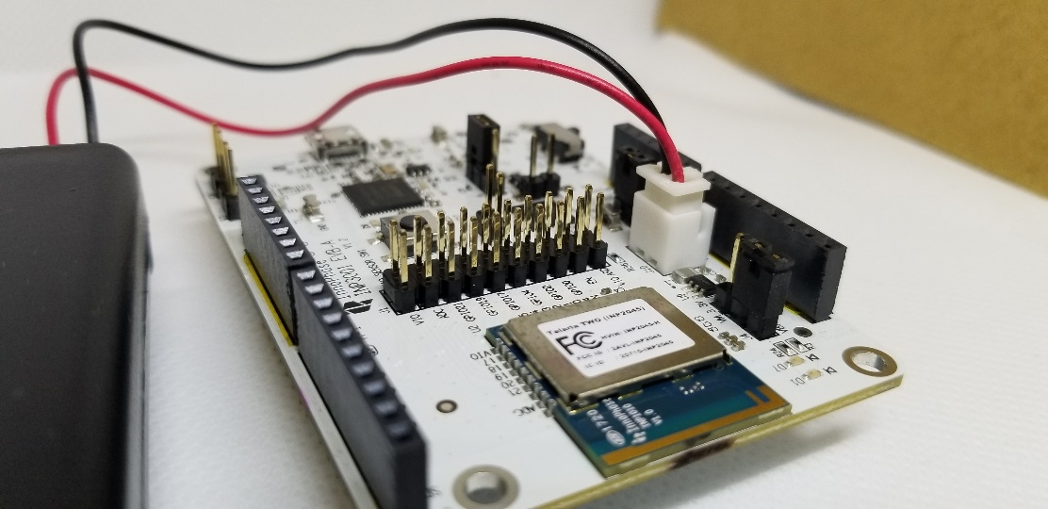

Figure 10: J10 Battery connection

**Note**: When using a battery as a power source there will be an additional current draw from LED (D7 or D12 depending on board version). If attempting to measure an accurate module current draw from the battery connection, the LED series resistor must be removed to disconnect the LED.

For more information on the Wi-Fi Connection Manager’s power management APIs, refer: the Wi-Fi Power Management application note.